35. Write a Java program to display the following pattern.

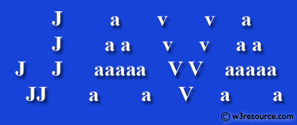

public class Exercise35 {

public static void main(String[] args) {

System.out.println(" J a v v a");

System.out.println(" J a a v v a a");

System.out.println(" J aaaaaa v v aaaaaa");

System.out.println(" J J a a vv a a");

System.out.println(" JJJ a a vv a a");

System.out.println("----------------------------------------");

}

}